1. We need to have a couple of micro services in place so that we can take the spring components and plug them in wherever and however required.  
   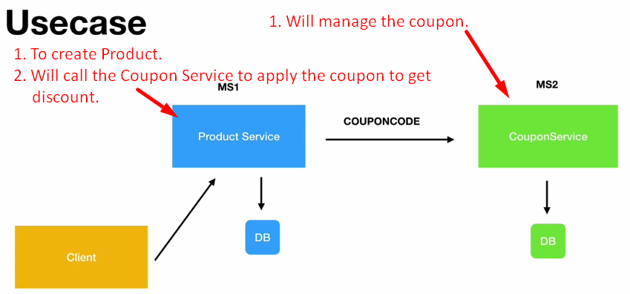
2. **Outline**:
   1. We will create two microservices.
      1. Product Microservices.
      2. Coupon Microservices.
   2. These microservices would expose the RESTful API which will allow
      1. An end user to create a Product.
      2. In the process, the product service will use the coupon service to apply a coupon code that the client passes in and gets the discount.
      3. The product service is responsible
         1. To create a product in DB along with its price and description details that a client passes.
      4. Coupon Service exposes some API such as
         1. One to create coupons.
         2. 2nd to get the coupon details through the coupon code.